CSC 5521 – Intro to Machine Learning

HW1

Saksham Goel

goelx029 | 5138568

|  |  |
| --- | --- |
| **Question #** | **Pages** |
| Question 1 | 1-2 |
| Question 2 | 3-9 |
| Question 3 | 10-11 |
| Question 4 | 12-15 |

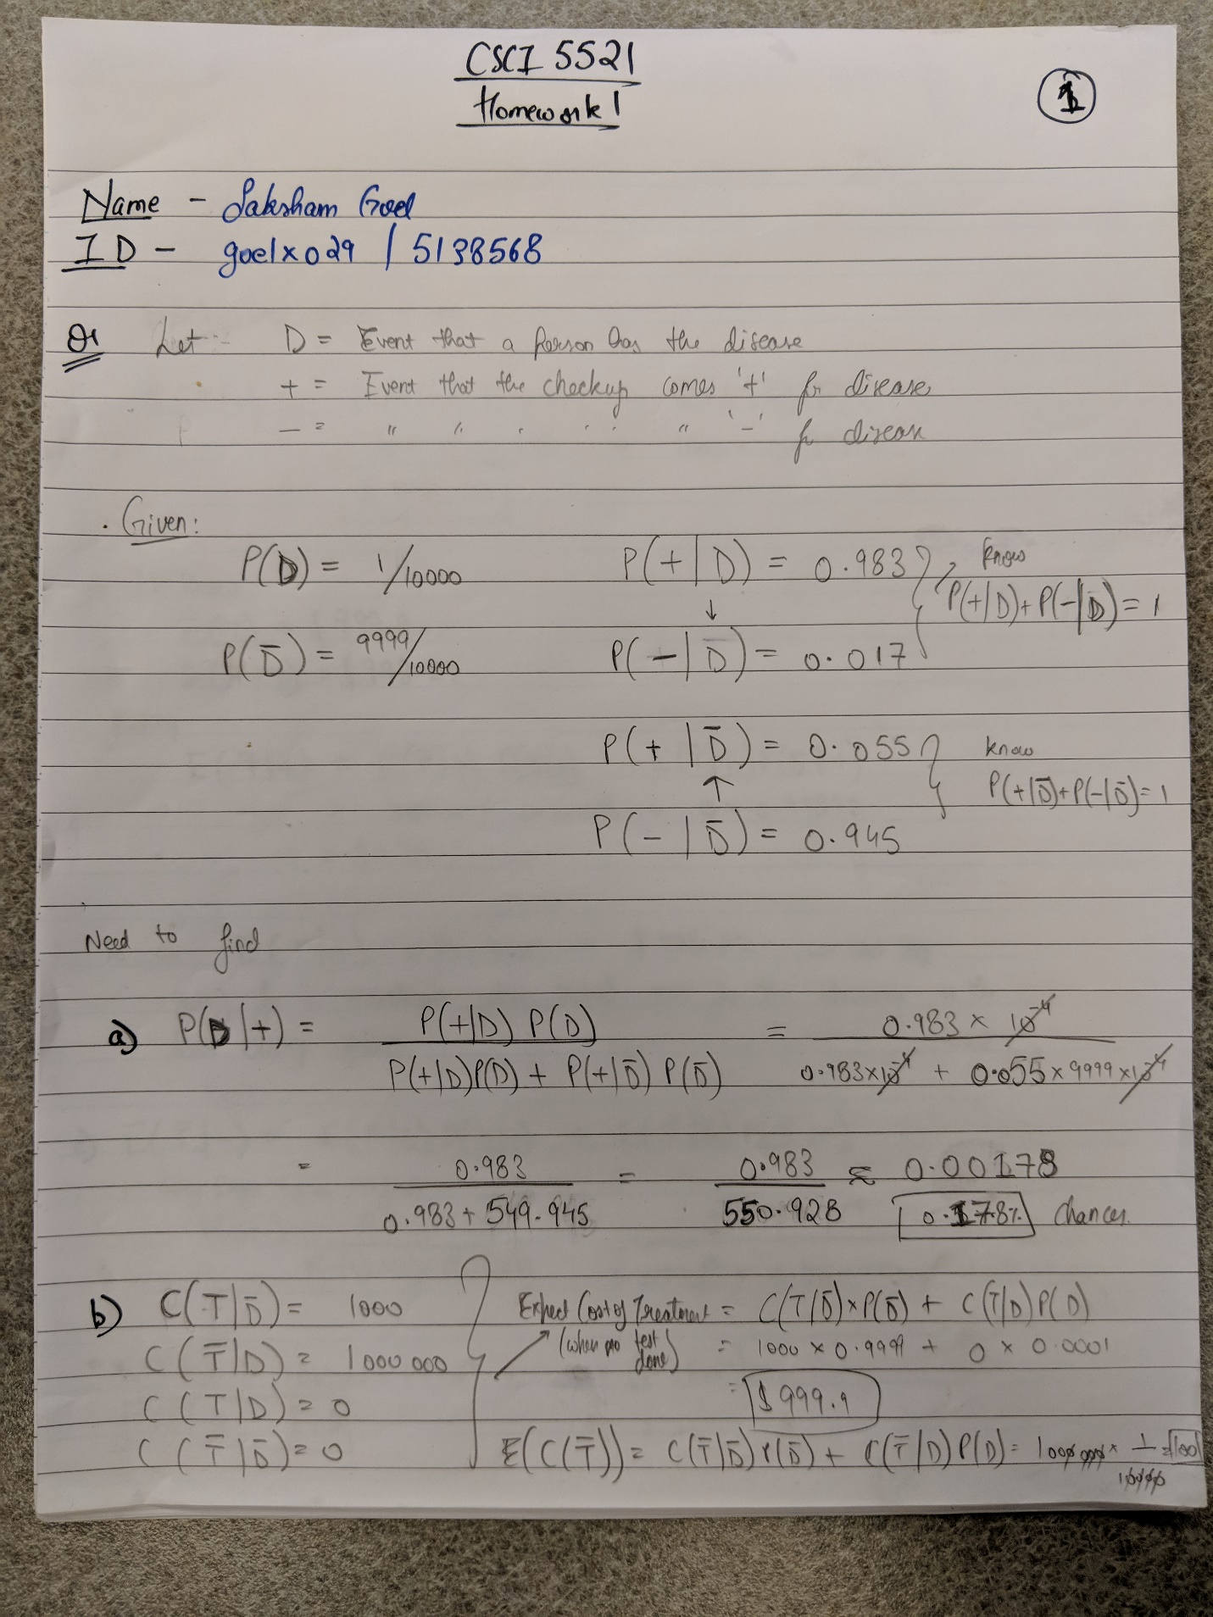

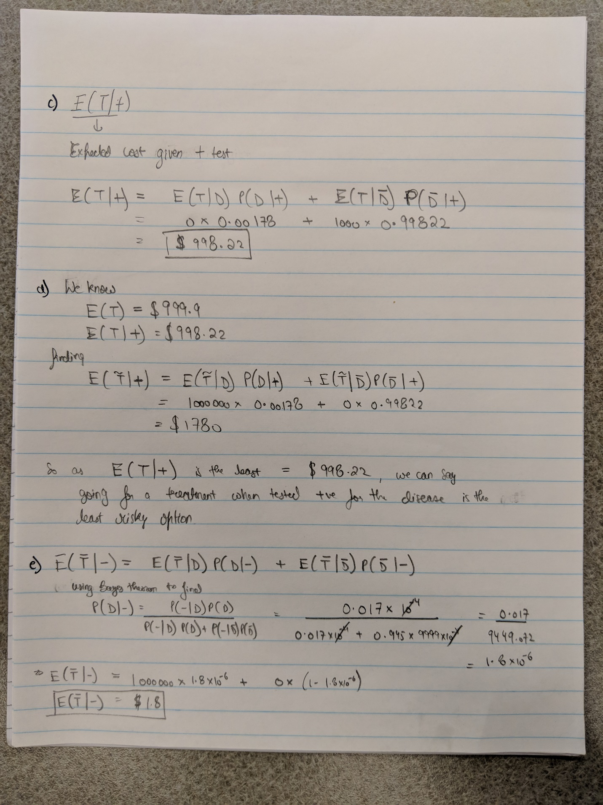

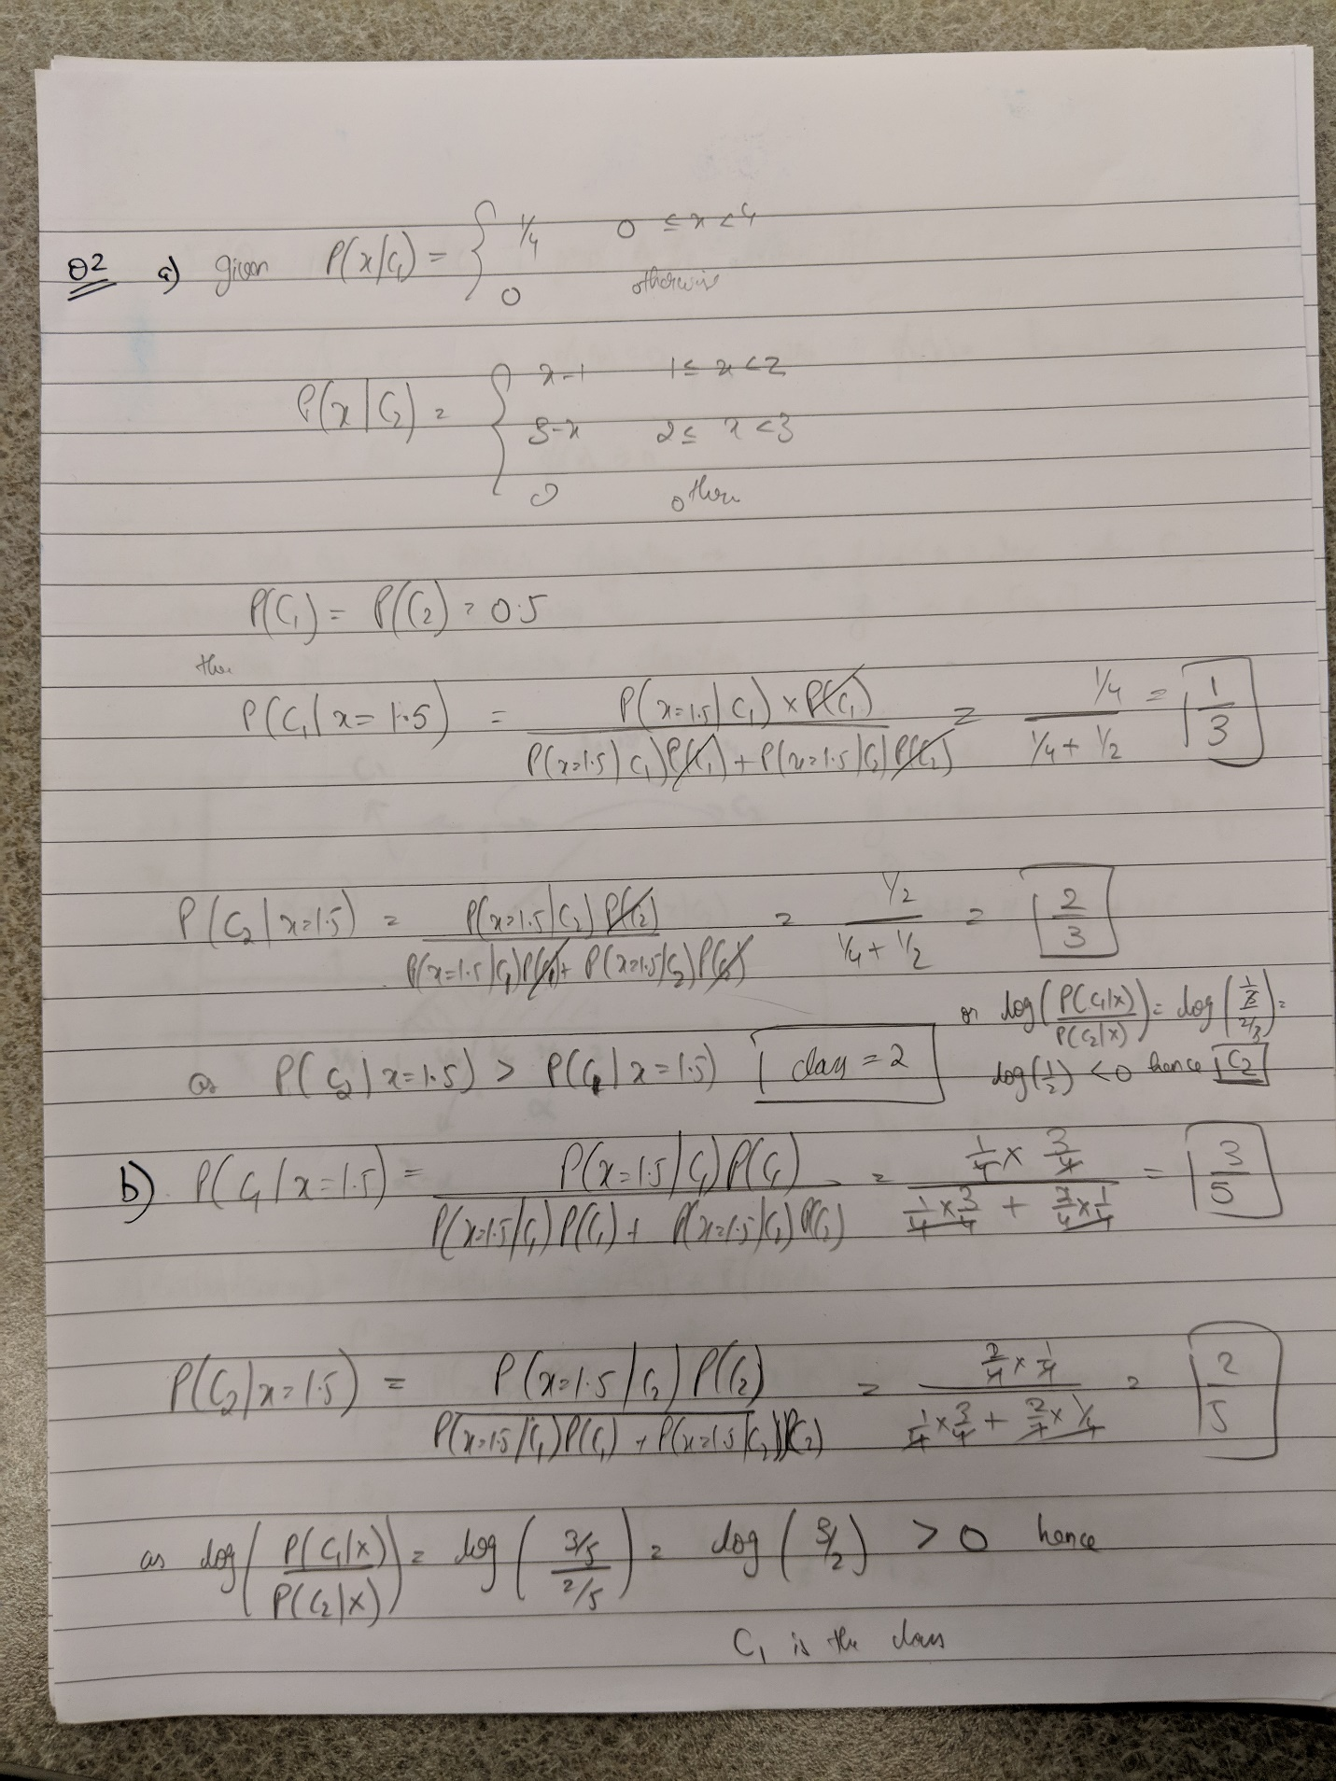

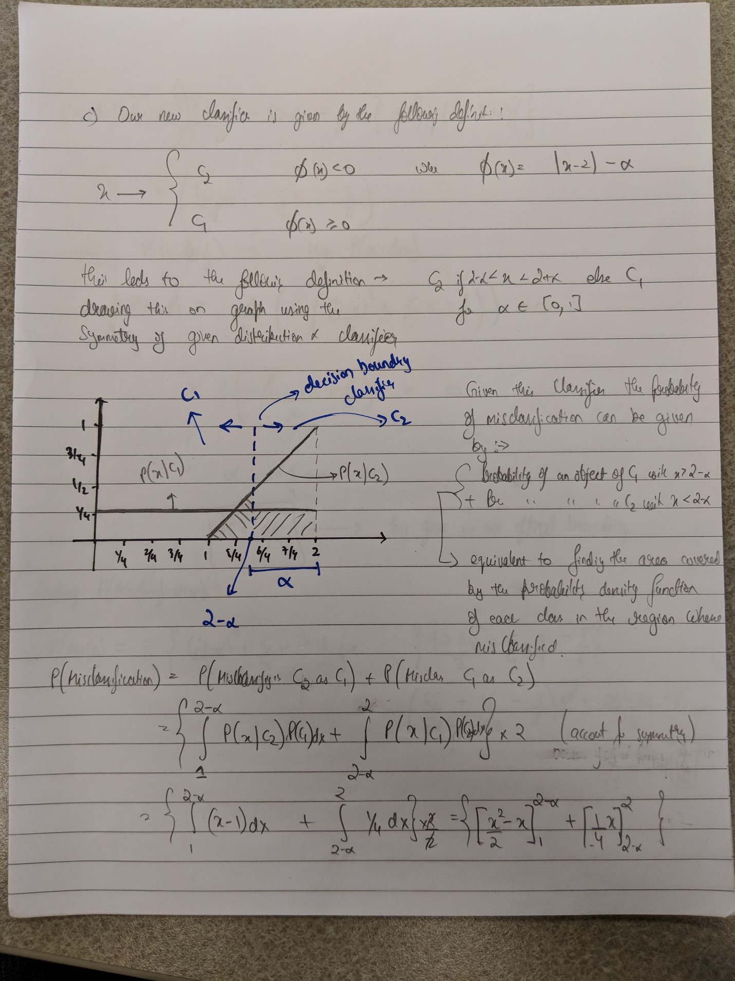

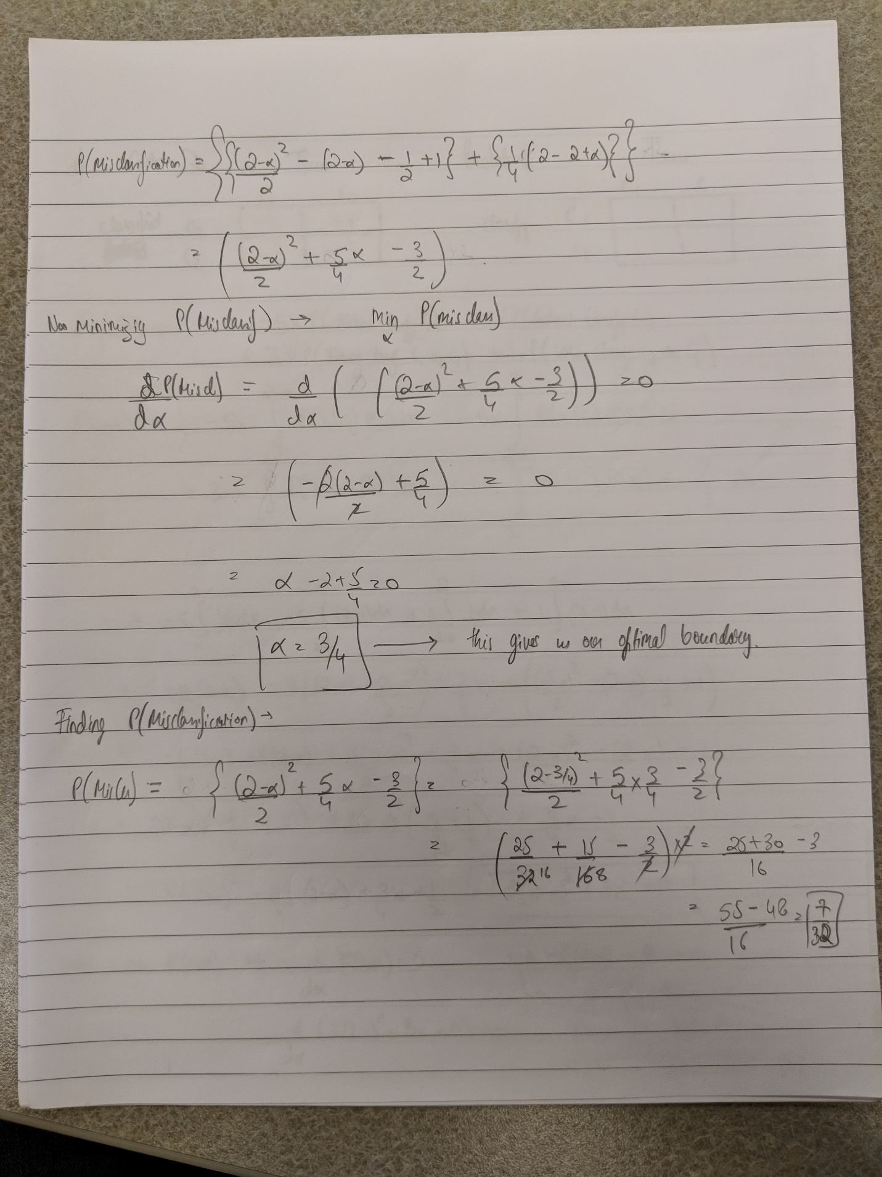

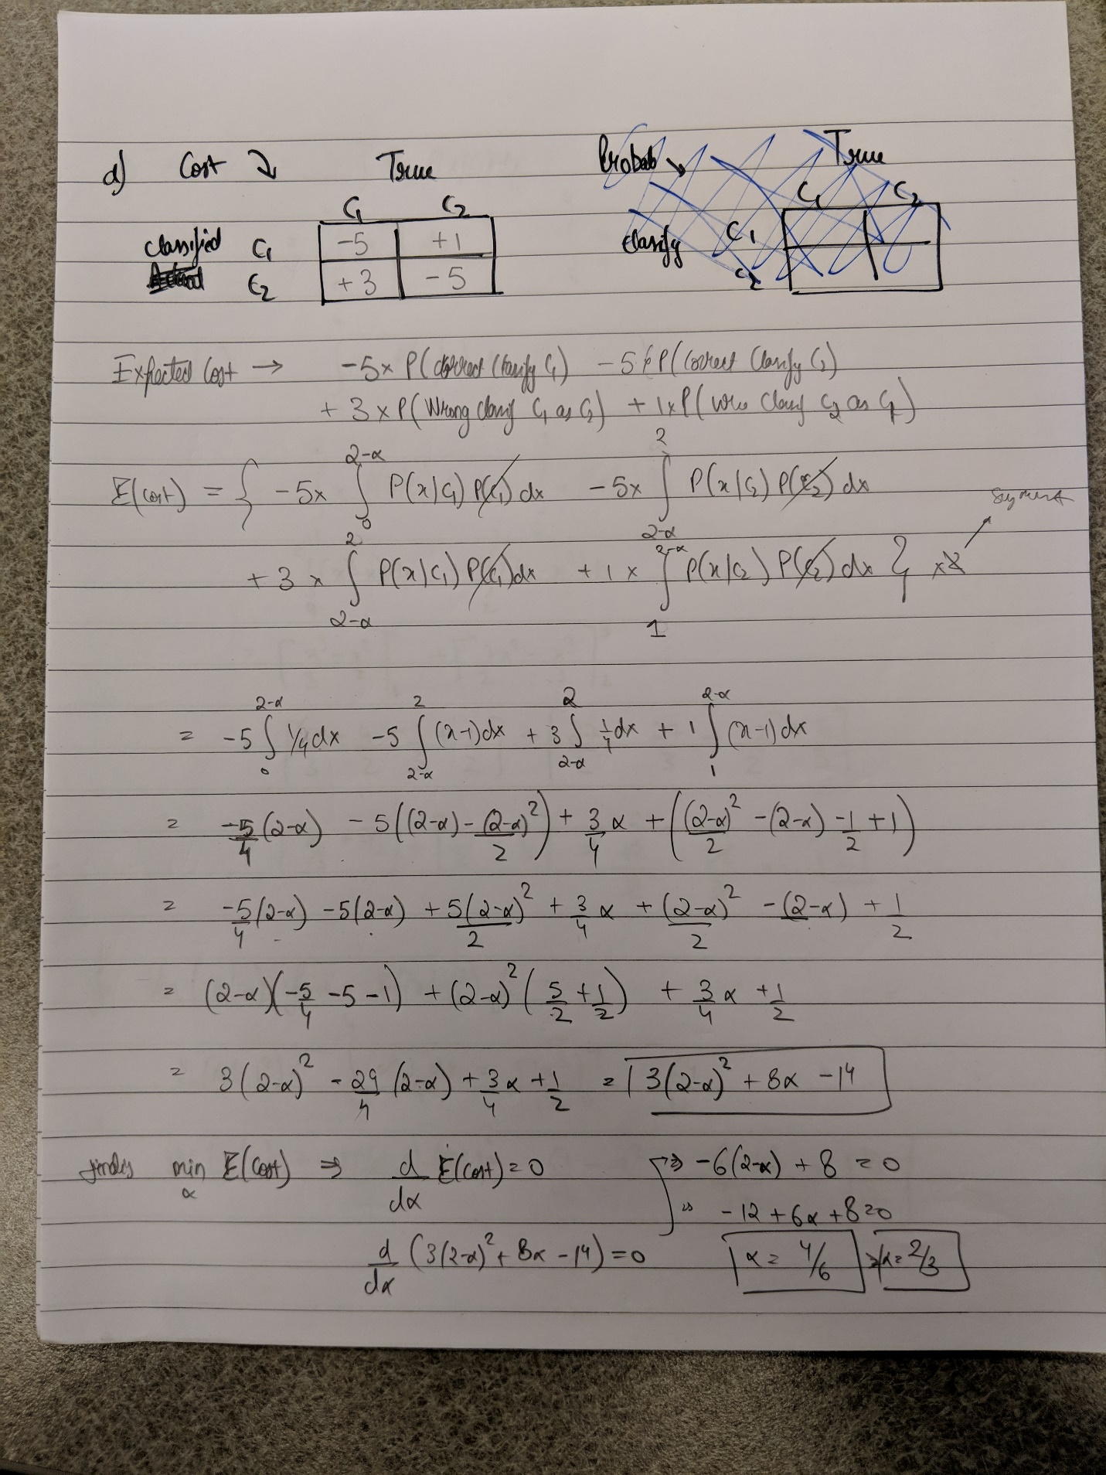

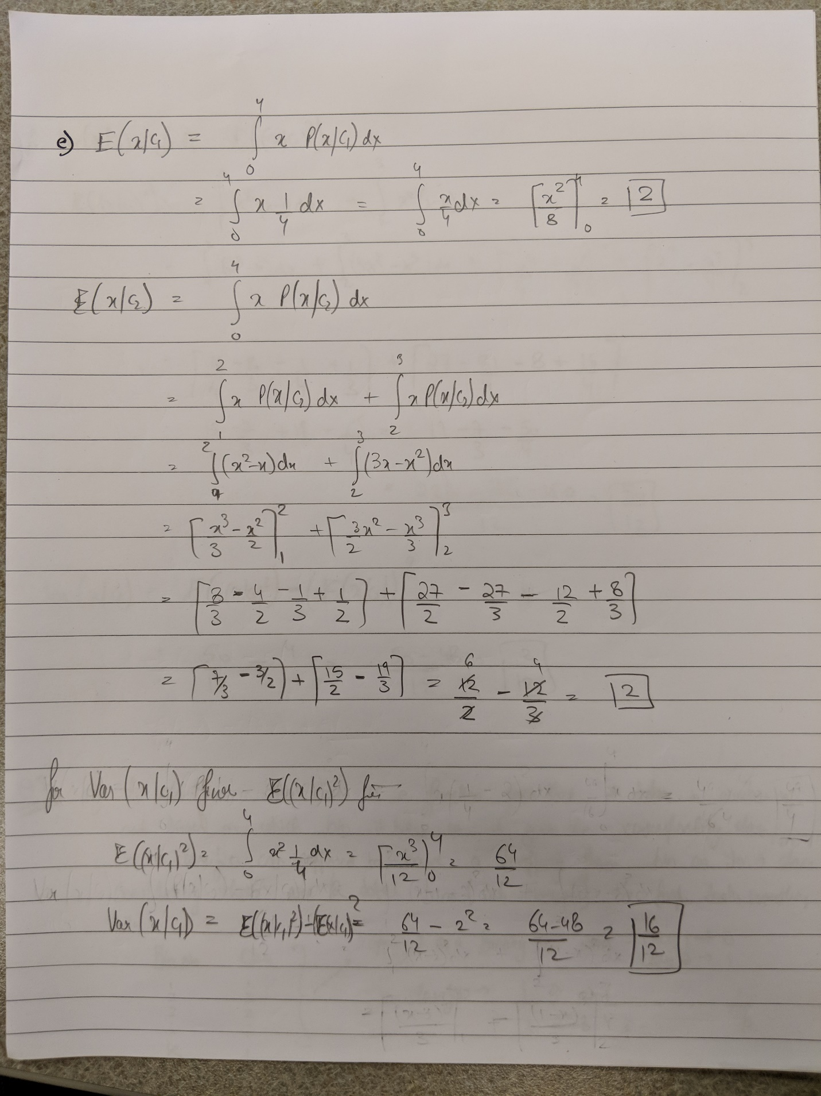

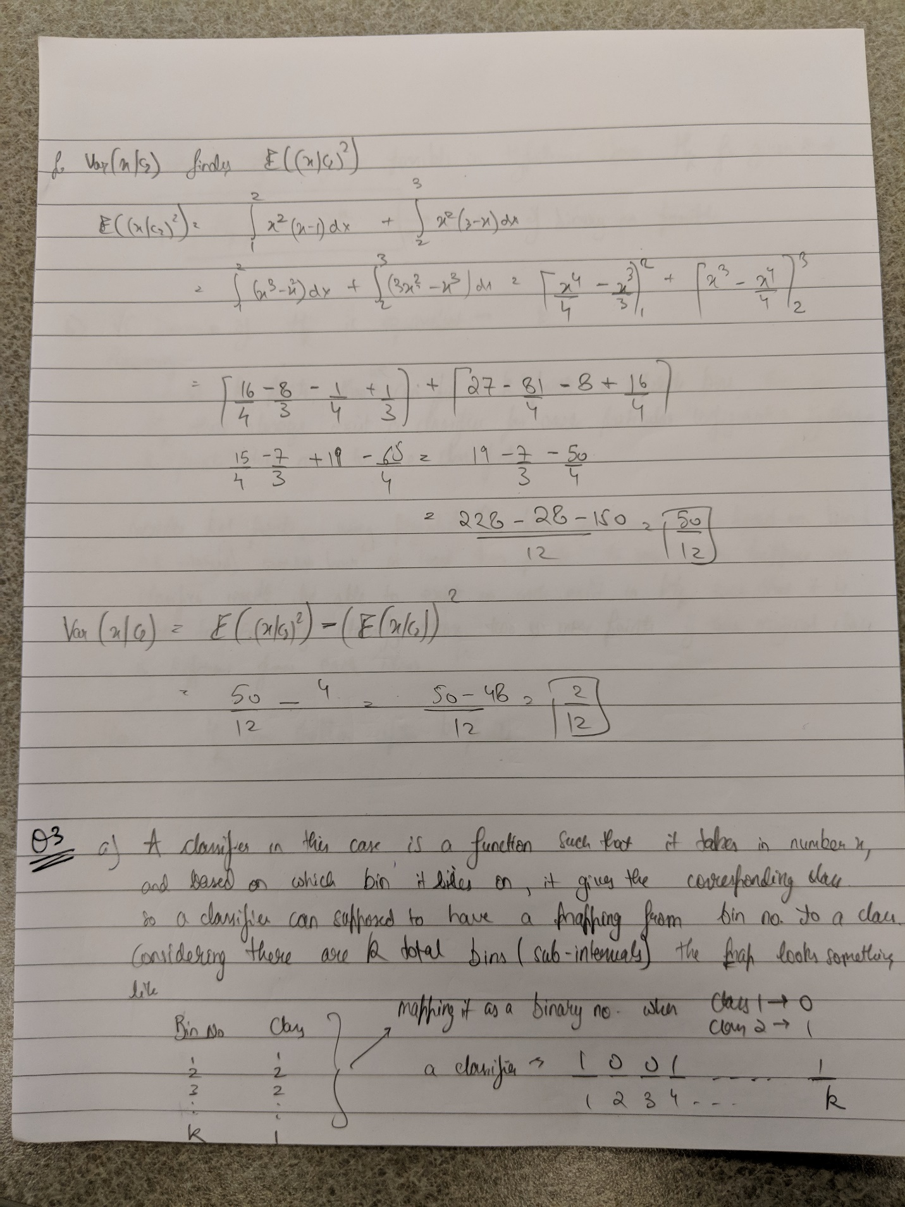

Standard Deviation (x | C1) = sqrt(4/3) = 1.1547

Standard Deviation (x | C2) = sqrt(1/6) = 0.4082

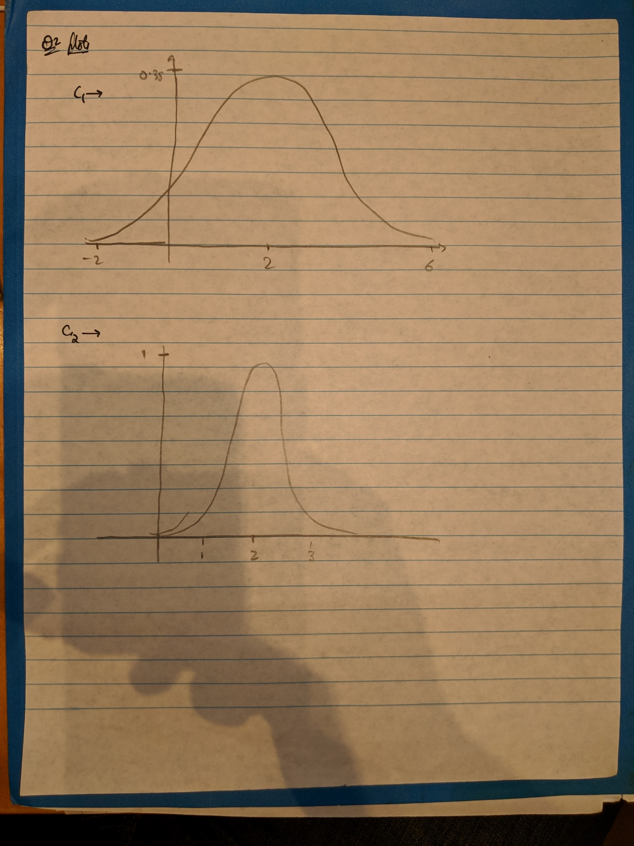



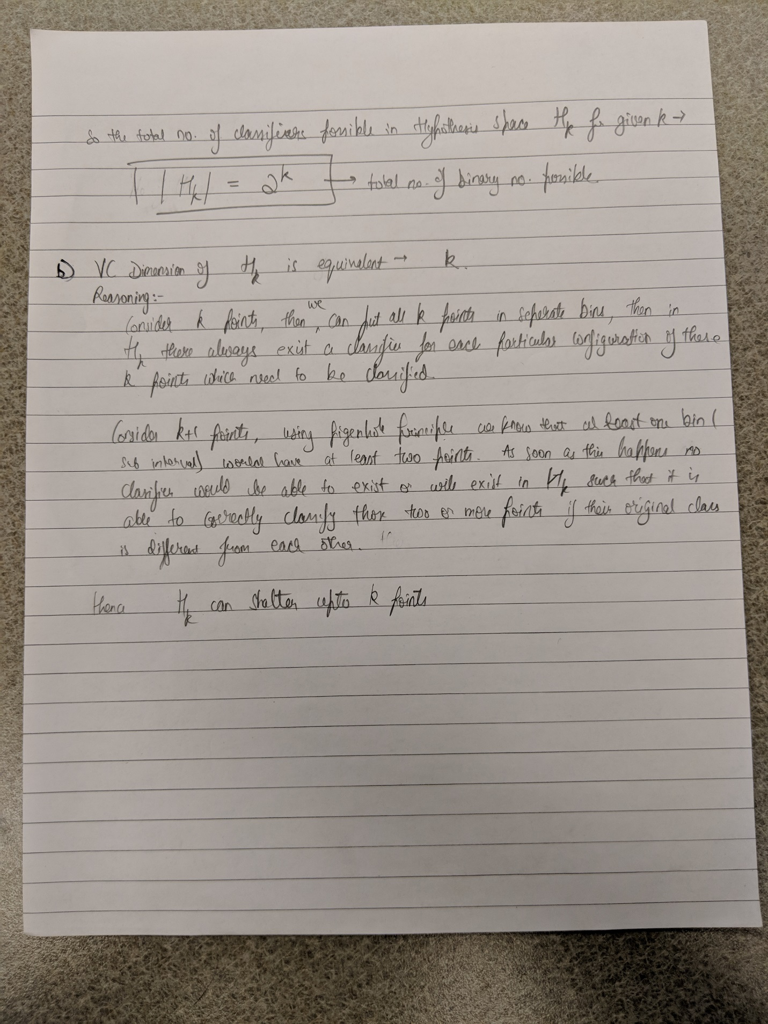

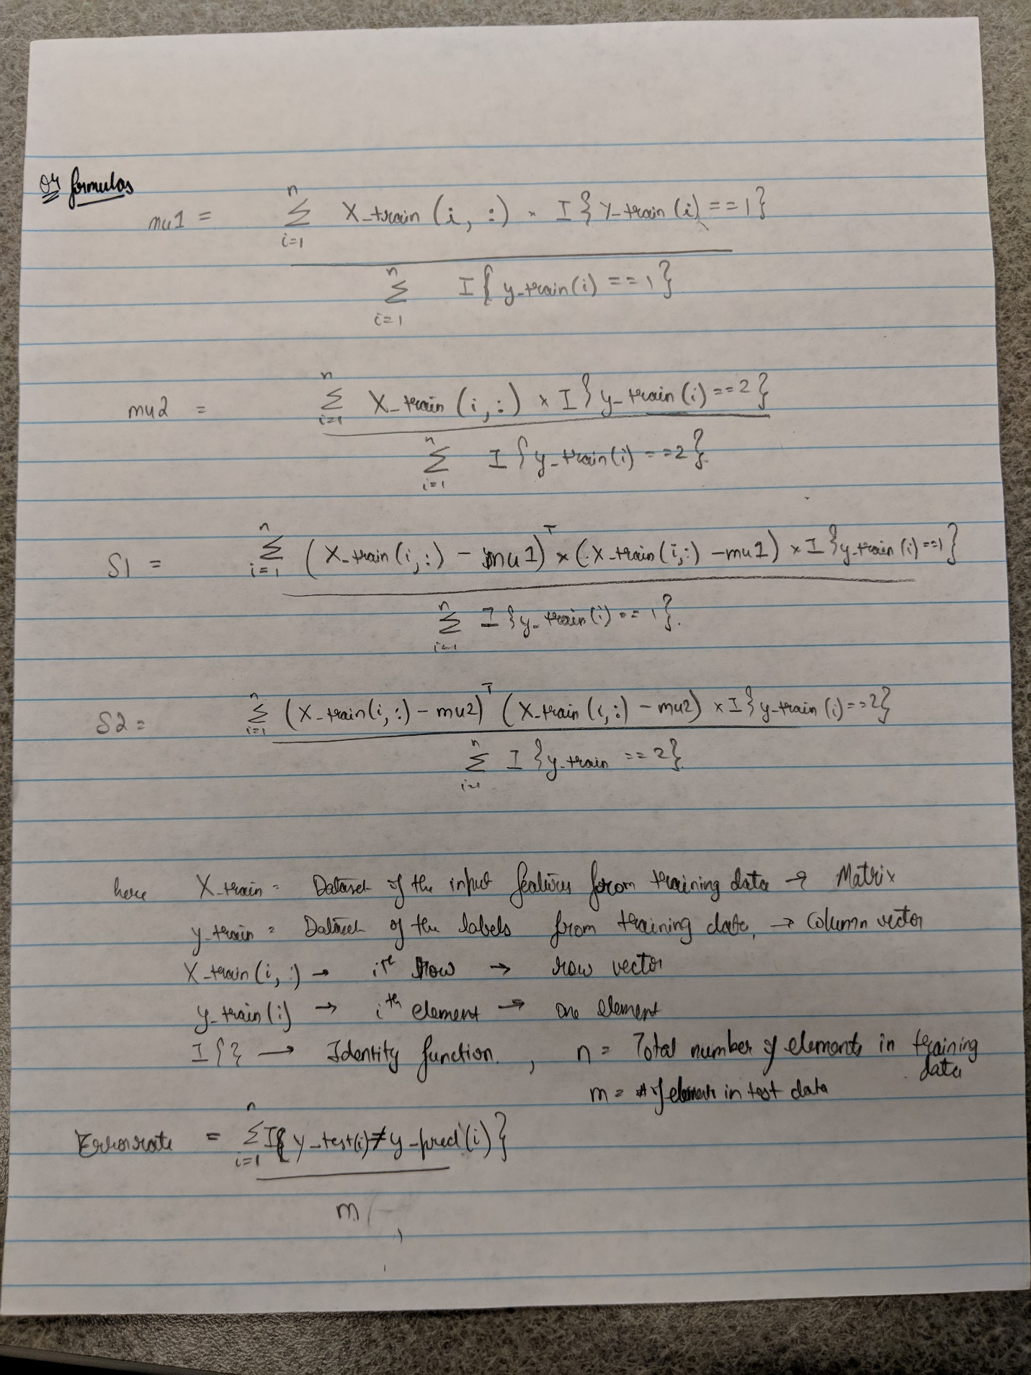

[mu1, mu2, S1, S2, ConfuisonMatrix, ErrorRate] = classify('./data/training_data.txt', './data/test_data.txt')

mu1 =

1.0554 2.5181 3.2967 -1.8927 -1.3918 4.0635 -4.3540 -5.8705

mu2 =

3.8052 5.3740 5.7333 1.1596 1.1777 6.8000 -2.0286 -2.5044

S1 =

0.9729 0.7135 0.4570 0.8938 0.3096 0.1975 0.7362 1.6629

0.7135 3.0658 2.5982 0.3878 1.2994 0.1442 0.9168 4.9388

0.4570 2.5982 6.6612 0.9084 1.6397 0.8148 0.0779 5.4168

0.8938 0.3878 0.9084 5.0754 0.0963 1.0611 2.3978 4.5946

0.3096 1.2994 1.6397 0.0963 2.3973 -0.0191 0.2175 2.5378

0.1975 0.1442 0.8148 1.0611 -0.0191 1.0412 -0.0531 1.8604

0.7362 0.9168 0.0779 2.3978 0.2175 -0.0531 6.5154 3.8609

1.6629 4.9388 5.4168 4.5946 2.5378 1.8604 3.8609 17.0931

S2 =

1.3486 0.8658 0.1559 0.5847 0.9473 0.2543 0.3705 0.9435

0.8658 2.8161 -0.1819 0.2152 0.7141 0.6797 -0.2383 2.4194

0.1559 -0.1819 6.6734 1.7716 1.0318 0.6526 1.6795 3.8992

0.5847 0.2152 1.7716 3.5433 0.3570 1.3665 2.1207 3.0899

0.9473 0.7141 1.0318 0.3570 2.7517 0.1225 1.4342 2.4651

0.2543 0.6797 0.6526 1.3665 0.1225 1.8107 0.3445 1.5113

0.3705 -0.2383 1.6795 2.1207 1.4342 0.3445 7.1134 2.6246

0.9435 2.4194 3.8992 3.0899 2.4651 1.5113 2.6246 13.9151

ConfuisonMatrix =

24 11

6 59

ErrorRate =

0.1700